# TIPS TO AVOID SCRATCHING

Scratching is a completely normal cat behavior that is done for a multitude of reasons, such as marking their territory and stretching their muscles. Declawing is an inhumane process that involves amputation at the first joint of each digit on a cats’ paws, ensuring there will be no nail regrowth. This typically leads to a lifetime of pain and behavioral issues from your cat, like biting and refusal to use the litter box. DECLAWING IS NEVER THE ANSWER! Here are some of our tips and tricks that you can use to avoid unwanted scratching from your cats:

**>Your cat should have MULTIPLE options when picking something to scratch.** The most popular choices are usually cardboard scratching boards and sisal wrapped posts. These will have to be replaced periodically as they wear down over time. Tip: encourage your cat to use these items by spraying them with catnip spray

**>If you have furniture that you want to preserve from claw marks, there are a few options.** One way to immediately deter cats is by lining the areas your cat targets with double sided tape. Another simple solution that you may find success with is making a solution of lemon juice and water, then spraying this on the furniture your cat tends to scratch. The acidity has an unpleasant taste and smell to cats (when spraying on cloth, make sure you do a patch test first before covering an entire item of furniture!)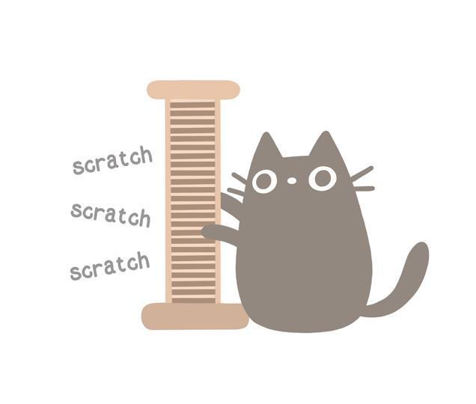

**>Make additions to your home that allow your cats to have their own space.** Give them somewhere they can retreat that’s high up off the ground— Chewy.com has tons of affordable, high quality cat condos to pick from! You can also install shelves and window perches where your cat can lounge and play

**>If possible, you should make attempts to keep your cats’ nails trimmed so they don’t accidentally injure themselves when scratching.** We know it’s tough to do at home, so you may want to leave this part up to a professional!

**>Put claw caps on your cats nails.** Claw caps are inexpensive and painless for your cat. They will keep your cats nails encased in a flexible plastic/rubber that prevents them from scratching themselves and others, as well as your belongings. The can last for up to six weeks before needing to be replaced. Plus, they come in all colors, so you can pick whichever shade suits your cat best!